|  |  |
| --- | --- |
| **Nikon Z5 Camera**  Máy ảnh Nikon Z5 +Lens 24-200mm f/4-6.3  Nikon Z5 with lens 24-200 1 Nikon Z5 with lens 24-200 2 Nikon Z5 1 Nikon Z5 2 | **Featured information:**   * EXPEED 6 image processor * 24.3MP CMOS sensor * 3.6 million-dot OLED electronic viewfinder * Record UHD 4K and Full HD videos   Price : 2000$  **Specifications:**   * **Sensor Format:** Full-Frame (1x Crop Factor) * **Resolution:** 24.3 megapixels * **Size photo:** 6016 x 4016 * **Image Proportions:** 1:1, 3:2, 16:9 * **Sensor Type:** CMOS * **Image Format:** JPEG, Raw * **Anti-Vibration:** Sensor-Shift, 5-Axis * **Lens Mount:** Nikon Z |

**Description:**

#### **24MP CMOS Sensor & EXPEED 6 Processor**

The Nikon Z5 possesses a 24.3MP full-frame CMOS sensor combined with the EXPEED 6 image processor to provide fast, accurate processing performance and high image quality. In addition, the ISO range of 100 - 51200 (expandable to 102400) allows users to take photos in all lighting conditions, enhancing noise control, providing clean and detailed photos. In addition, the EXPEED 6 processor also allows continuous shooting at 4.5 frames per second as well as the ability to capture 8MP when recording video.

#### **Some other features of Nikon Z5**

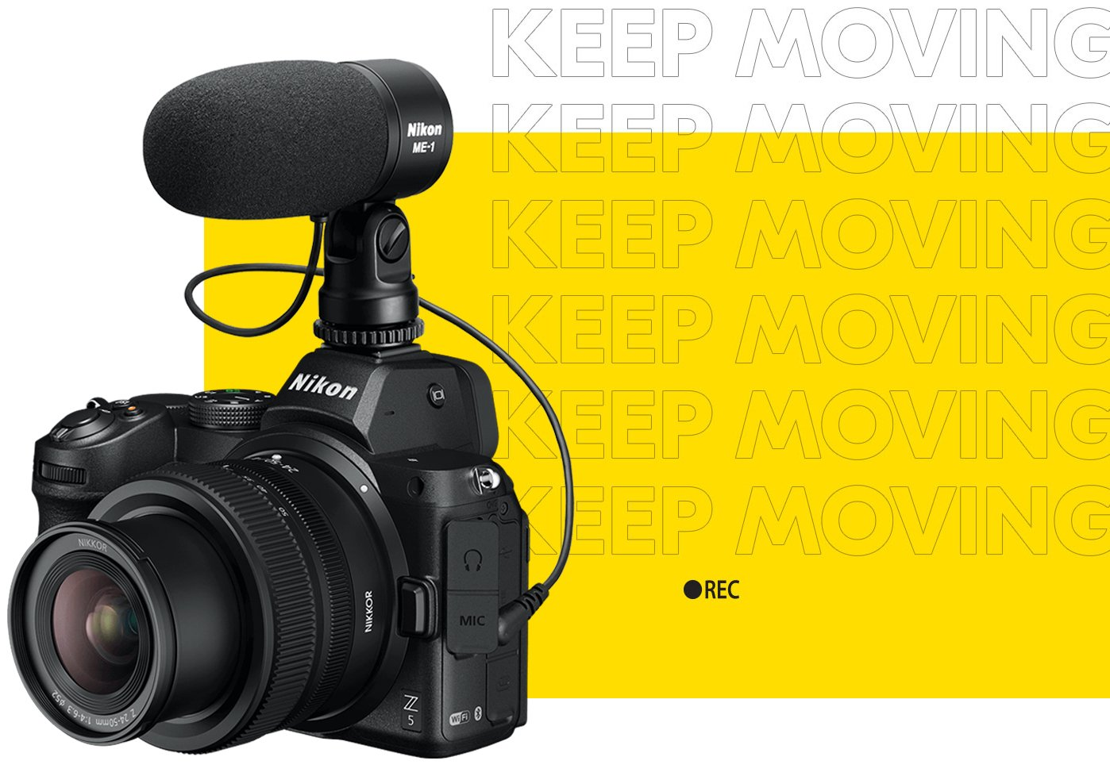

Not only does it take high-quality photos, the Nikon Z5 also supports UHD 4K video recording (1.7x crop) at up to 30 frames per second and Full-HD 1080p recording at a maximum speed of 60 frames per second. Users can choose the location to store video files on the device's internal memory card or external memory via HDMI output.

